Head Judge: Michał Mazurek, Klub Kyudo Tametomo Mysiadło

Schedule

Friday 31st of May
7:30 Team registration, briefing and question time in the dojo

8:00 – 9:30 Jiyū renshū

Saturday 1st of June – Team Competion
10:00 Rei and Yawatashi

10:15 –10:30 Drawing of team order

10:30 – 13:00 Team competition
20 Arrows each, according to Heki students competition rules
12 arrows before lunch, 8 after

13:00 – 14:00 Lunch at Sports Center
14:00 – 16:00 Team competition.
After lunch 8 arrows

19:00 Individuals’ registration, briefing and question time in the dojo
Each team can send one archer to the individuals competition.

19:30 – 21:00 Jiyū renshū

Sunday 2nd of June - Individual

10:00 Rei

10:10 – 10:30 drawing of starting numbers

10:30 – 13:00 Individuals competition
20 Arrows each, according to Heki students competition rules

13:00 – 14:00 Lunch at Sport Center

14:00 – 14:30 Winner’s presentation Ceremony

14:30 – 14:45 Heki Taihai by the winning team

14:45 – 15:00 Closing Rei

Instructions for team competition

Friday evening at 8 p.m. the team shooting order will be drawn by one arrow of the captain.
3 teams will shoot at the same time for 5 rounds, 4 arrows each archer.
The three teams walk in and out with YU to the kamiza and wait at the honza line for the sign of the judge- ‘hajime’. Then each team one after another proceeds with kiai (TO-HO) to the shai.

Arrows of all team members will be placed in an appropriate arrow-holder according to the draw order closed by.
Every shooting position will have one arrow-holder. Kanteki will bring back shot arrows into these.

All team archers will have to wear the numbers on the right-hand side of the hakama, substitute archer included. The team order will be defined by the number drawn.
Each team with a substitute archer, a trainer or a companion kyudoka, must define one of them as competition Assistant. In case the team has only 3 members, the organization will provide an Assistant.
The Assistant’s duty will be:
• to stand at the honza line holding the team tsurumaki and being ready to provide a new string in case of bow string snapping,
• to provide fudeko even during competition.
The Assistant is forbidden to check and correct aim, during competition, or directly intervene on the competing kyudoka shooting. The Assistant is allowed, if entitled, to give advices, when a shooter is in kiza while waiting his/her own turn to shoot.

Please, be always on time for your shooting turn, in order to avoid useless waste of time, and so affecting the competition timing.
At the end of each team round, the following teams will have to reach the Honza line after judges have completed the shooting registration of previous teams and the Mato judge has given out the word “dòzo”.
At the competition each archer will shoot 20 arrows probably 8 in the morning and 12 in the afternoon.

Team competition rules

The tachi is made of 3 archers.
The Heki team competition is carried out with each archer shooting a total of 20 arrows.
The competition ceremony will be the one used by Japanese students and archers will shoot 4 arrows each round.
Arrows will be valid if hitting the target and staying there in place.
Arrows will not be considered valid if:

- not completely inserted into the target (inside at the mato face).

In case an arrow hits a previous arrow shot into the mato and it is diverted outside the target or it is bounced back, the arrow is not considered valid, unless it gets stuck into a valid one and off the ground.

- hitting the target after having touched the ground or any other obstacle.

- hitting the target of another shooter, even if belonging to the same team.

- released before the preceding archer has released its own, in the team order.

- falling down after having completed yugamae. In that case the archer will not shoot that arrow and a judge will collect it.

In case of bow string snapping the archer must close his/her shooting as if going back to Honza making two little steps backwards in order to allow the assistant to fetch easily the bow and replace the string. The archer will stay in Kiza waiting for the strung bow to be brought back to him/her. Then he/she will move to the Shai line in order to carry on with his/her turn.

Please make sure you check your scoring at the azuchi area each round. If you don’t agree in any case please bring up your complain straight away to the shai judge otherwise there will not be a correction afterwards.

If an archer, during the competition, is of any hindrance or damages of another kyudoka during his/her shooting, the kyudoka can ask the Shai judges, just after the end of his/her turn, to repeat that arrow, unless the archer provoking the damage belongs to the same team.

In case of same score between two or more teams, within the first three positions, a deciding shooting (play-off) will be carried out.
The teams start with two arrows each. After shooting their haya they return to the honza and wait in Kiza for the result. And case of another draw they shoot their otoya as well and walk out.

For any complaint or doubt, the verdict from the mato judge and the Shai judges is one and unquestionable.

Instructions for individual competition

Saturday evening is the deadline for all teams to name the single archer, who will participate at the individual competition. The tachi will be defined by draw.

The competition will be performed by tachi of at most twelve archers shooting at the same time 4 arrows each for 5 rounds.

In this competition Kiai will be made only once at the beginning by the first tachi.

Like for the team competition an assistant per tachi is requested for keeping tsurumaki and providing fudeko.

Individual competition rules

One archer of each registered team will take part at the individual competition.
The individual competition is carried out with archers shooting 20 arrows each.
The competition ceremony will be the one used by Japanese students and the archers will shoot 4 arrows each round.

Arrows will be valid if hitting the target and staying there in place.
Arrows will not be considered valid if:

- not completely inserted into the target (inside at the mato face).
In case an arrow hits a previous arrow shot into the mato and it is diverted outside the target or it is bounced back, the arrow is not considered valid, unless it gets stuck into a valid one and off the ground.

- hitting the target after having touched the ground o any other obstacle.

- hitting the target of another shooter.

- released before the preceding archer has released its own, in the team order.

- falling down after having completed yugamae. In that case the archer will not shoot that arrow and a judge will collect it.

If an archer, during the competition, is of any hindrance or damages another kyudoka during his/her shooting, the damaged kyudoka can ask the Shai judges, just after the end of his/her turn, to repeat that arrow.
In case of string snapping, the archer has to close the shooting as if going back to Honza, by making two little steps backwards, in order to allow the assistant to take easily the bow and replace the string. The archer will be waiting in kiza position for the strung bow to be brought back to him/her. The archer will then go back to the Shai line to carry on shooting.

Please make sure you check your scoring at the azuchi area each round, if you don’t agree in any case please bring up your complain straight away to the shai judge otherwise there will not be a correction afterwards.

In case of same score between two or more archers within the first three positions a deciding shooting (play-off) will be carried out.
For any complaint or doubt, the verdict from the Mato Judge and the Shai Judges is one and unquestionable.

Some information for your stay in Warsaw …

In your welcome package you find badges for lunch which will be served at the training hall and T-shirt in the size declared in the application.

There is free WiFi in the Sport Center. Please ask our support team for login.
At the hotel DeSilva there will be free WiFi service available, please the hotel reception desk for detail on longin

We ordered spare T-Shirts in all sizes. In case your ordered shirt doesn´t fit, you may have the chance to get another size. Please ask one of the Taikai staff team for help on that

On Sunday you have to check out your room before 10 a.m. There will be a separate room for all the luggage. Change Rooms are located downstairs.

Please be prepared to pay your accommodation cost at the hotel Reception before leaving. Car parking fee is 28 PLN per 24 hour, you will pay this also at the Reception. They accept Cash, EC-Card and credit cards.

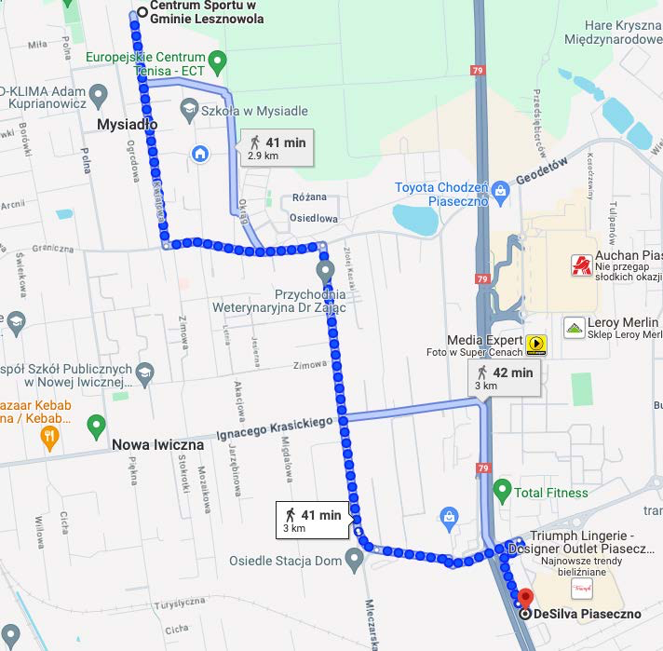
The route between the hotel and the Sports Center – 41 min walk.

During your stay in Warsaw there will be arranged a bus service between DeSilva Hotel and the training hall

The bus schedule between DeSilva Hotel and the training hall

Thursday 30 of May
09:00 | DeSilva | -> | Training hall
17:30 | Training hall | -> | DeSilva
Friday 31of May
09:00 | DeSilva | -> | Training hall
17:30 | Training hall | -> | DeSilva
19:00 | DeSilva | -> | Training hall
21:30 | Training hall | -> | DeSilva
Saturday 1st of June
09:00 | DeSilva | -> | Training hall
17:00 | Training hall | -> | DeSilva
18:00 | DeSilva | -> | Training hall
21:30 | Training hall | -> | DeSilva
Sunday 2nd of June
09:00 | DeSilva | -> | Training hall
15:30 | Training hall | -> | DeSilva

